 | 
UNIT DETAILS:
Unit code | COS30045
Unit name | Data Visualization
Lecturer | Rishma Fathima Basher
Assignment | Beyond the Fine: Visualising the Disparities in Australian Road Enforcement Actions
Tutorial Day | Time | Monday - Friday | 6:00pm to 10:00pm
Section | C1
Session | March 2026
Semester | 1
Word Count | 5512

GROUP 4 STUDENTS DETAILS:
Student Name |  | Student ID | Signature
(1) | Gain Jin | 106627722
(2) | Kwan Kian Ann | 106627719

Table of Contents
1.0 Introduction 2
1.1 Background & Motivation 2
1.2 Visualization Purpose 4
2.0 Data 5
2.1 Data Source and Governance 5
2.2 Data Processing and Analysis 7
2.3 Data Exploration 9
3.0 Visualisation Design 10
3.1 Website Design 10
3.2 Visualization Design 13
3.3 Interaction Design 15
4.0 Iteration and Validation 16
4.1 Testing and Refinements 16
4.2 Usability Evaluation 24
5.0 Conclusion and Future Improvement 28
5.1 Key Findings and Lessons Learnt 28
5.2 Future Improvements 29
References 30
Gen AI Declaration 31

1.0 Introduction

1.1 Background & Motivation
Across Australia, road traffic accidents continue to be a significant public health and economic concern. Identifying the most effective methods to reduce these crashes requires a rigorous, evidence-based approach to enforcement. The Bureau of Infrastructure and Transport Research Economics (BITRE) has maintained comprehensive records of road safety enforcement activities such as spanning speeding, seatbelt non-compliance, mobile phone usage, and drug testing since 2008.
Historically, this data was published in a highly aggregated format. However, to account for the complex demographic and geographic characteristics driving road infractions, BITRE updated its collection methodology in 2023. The dataset now features fine-grained, multi-dimensional variables, including precise geographical typologies, age group breakdowns, and crucially, the distinction between monetary fines, direct arrests, and formal criminal charges stemming from the same offence.
A significant drawback of BITRE’s current official Police Enforcement Dashboard is its reliance on summary-level data, which fails to reflect this new structural depth. This oversight masks critical public safety narratives. Academic research has long highlighted the tension between automated enforcement and manual police intervention; while automated cameras are highly effective at mass compliance, they are often critiqued by the public as revenue-generating rather than safety-focused, whereas manual policing is proven to be essential for intercepting high-risk behaviours like unlicensed driving or intoxication (De Pauw et al., 2014; WHO, 2023). Without visualising these discrepancies, policymakers cannot accurately assess whether automated cameras are functioning primarily as revenue streams, or if police presence is effectively deterring severe criminal traffic behaviour.

Target Audience:
- Primary: Traffic policymakers, law enforcement strategists, and road safety analysts. They require a diagnostic tool to evaluate the balance between automated enforcement and targeted police deployment.
- Secondary: The public and data journalism organizations focused on government accountability. They require transparent, interactive storytelling to understand who is being enforced against, where, and how.
Importance of the Visualization:
“Enforcement opacity” is a problem this project aims to solve. Existing dashboard tools provide only an aggregated total penalty count. Through this data collection and visualization, the data will be provided with context, by identifying the severity of the outcome (fine or arrest). This is very important for determining if the automated cameras are being used, primarily as a revenue generating tool and whether manual intervention by police officers is adequate for dealing with high-risk behaviours and repeat offenders.

Key User Tasks:
- Contrast the volume of automated camera detections against actual police-issued actions (arrests/charges).
- Identify specific demographic age groups most prone to receiving escalated enforcement (arrests) compared to monetary fines.
- Investigate geographic policing discrepancies (e.g., Major Cities vs. Remote areas).
- Examine temporal trends to determine seasonal or longitudinal shifts in enforcement strategies.

1.2 Visualization Purpose
This visualization is designed to answer the following core questions, translating raw enforcement logs into actionable intelligence:
- Severity Distribution:
For severe offences (e.g., unlicensed driving), what proportion results in standard fines versus arrests/charges? This reveals whether states rely solely on financial penalties or actively pursue criminal deterrence.

- Demographic Targeting:
Are younger demographics (17-25) over-represented in police-issued offences compared to automated camera detections, indicating targeted policing of high-risk age groups?

- Geographic & Methodological Discrepancy:
Does the primary detection method differ between 'Major Cities' and 'Remote' areas? (e.g., Is there a heavier reliance on manual police actions in remote areas lacking camera infrastructure?).

Benefits and Decision-Making Impact:
By explicitly visualizing “Arrests” and “Charges” alongside “Fines”, this dashboard actively shifts the policy narrative away from revenue generation and toward genuine crime deterrence. Policymakers can use this interface to justify resource allocation, for instance, identifying regions where low camera coverage necessitates increased police patrols, it is ultimately supporting more effective, behaviour-focused road safety strategies.

2.0 Data

2.1 Data Source and Governance
Original Data Source:
The dataset utilized in this project is the “Police Enforcement, Australia, 2024 (Fines)” dataset, directly sourced from the official Australian Government Department of Infrastructure and Transport (BITRE) Data Hub.
Web Link:
https://datahub.roadsafety.gov.au/sites/default/files/documents/police_enforcement_2024_fines.xlsx

Data Summary Table:
Table 1: Data Summary Table for Police Enforcement, Australia, 2024 (Fines)
Attribute | Description | Data Type | Example Value
Total Records | Total granular enforcement records in the file | Count | 12,179 rows
Key Dimensions | Dimensions added in BITRE's 2023 update | Categorical / Nominal | JURISDICTION, LOCATION, AGE_GROUP,  METRIC, DETECTION_METHOD
Key Metrics | Quantitative outcomes of enforcement | Ratio /  Quantitative | FINES,  ARRESTS,  CHARGES
Time Frame | The specific period covered by this dataset | Interval | January 2024  (Monthly snapshot)
Update Frequency | How often this specific granular data is released | Temporal | Annually

Data Collection & Quality Assessment:
The data is collected by state and territory police forces (e.g., NSW Police, VIC Police) and aggregated by BITRE to provide a standardized national view. Initial profiling via the KNIME Statistics Node revealed zero traditional NULL values. However, severe data quality issues presented themselves through mislabelled categorical values (e.g., Tasmania aggregates fixed and mobile camera data while other jurisdictions disaggregate them) and missing contextual data represented as strings (e.g., “Unknown” for age and location). Rather than treating these as dirty data, they were identified as valid “aggregate” or “undefined” categories requiring semantic remapping to prevent incorrect mathematical aggregation.

Security, Privacy, and Ethical Considerations:
Because the dataset is highly aggregated, there is no Personally Identifiable Information (PII) such as names, license plates, or exact addresses. The lowest level of granularity is age group and broad geographical region. Ethically, no individual can be identified from this dataset, making it fully compliant with Australian Privacy Principles (APPs). The data is used strictly for aggregate trend analysis.

Alignment with Section 1.2:
This dataset directly answers our core questions: Severity Distribution (by cross-referencing FINES with ARRESTS), Demographic Targeting (via the AGE_GROUP column), and Geographic Discrepancy (via the LOCATION column).

2.2 Data Processing and Analysis
Key Attributes and Data Types:
- Categorical (Nominal): JURISDICTION, METRIC, DETECTION_METHOD.
- Categorical (Ordinal): AGE_GROUP (e.g., 0-16, 17-25, 65 and over).
- Quantitative (Ratio/Count): FINES, ARRESTS, CHARGES (representing counts, no continuous ratios).

Data Cleaning Process:
To ensure absolute data integrity without artificially deleting any of the 12,179 rows, cleaning focused on Semantic Recoding rather than row filtration:
- Handling Missing Values: String Replacer nodes mapped “Unknown” to analytical constants: Unknown (Location) → All Regions, Unknown (Age) → All Ages, Unknown (Method) → All Methods. This preserves total counts while preventing erroneous aggregation.
- Normalisation: The START_DATE string (e.g., 2024/1/1) was manipulated to extract a clean, discrete MONTH variable, converting raw strings into a numerical dimension to reduce front-end rendering payload.
- Front-end Logic: Rows containing “All Methods” or “All Ages” are dynamically excluded during the D3 data-join phase (not deleted from CSV) to prevent mathematical double-counting when users filter for specific demographics.

KNIME Workflow Documentation:
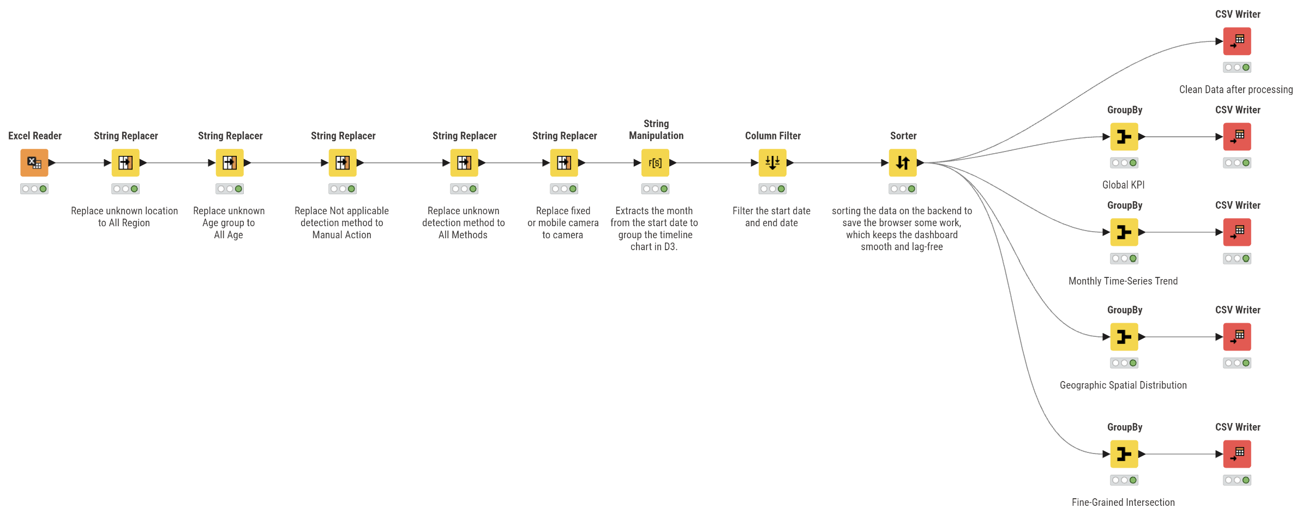
Figure 1: KNIME Data Processing Pipeline
As shown in Figure 1, our KNIME workflow consists of several distinct phases:
- Ingestion: The raw Excel file is read using the Excel Reader node, enforcing platform-independent paths for cross-platform compatibility.
- Semantic Recoding: Five sequential String Replacer nodes normalize categorical inconsistencies (e.g., mapping Tasmanian camera categories to Camera (Unspecified) and remapping “Unknown” to meaningful labels like Manual Action).
- Feature Engineering: A String Manipulation node extracts temporal data (MONTH) from the date string.
- Data Shaping: A Column Filter removes redundant metadata (HEAD, START_DATE) to reduce payload size.
- Materialized View Aggregation: The Sorter prepares the clean data for branching into 4 distinct GroupBy nodes. Each branch generates a specific CSV tailored for a D3.js component:
- Branch 1 (Global KPI): Aggregates total fines, arrests, charges for header cards.
- Branch 2 (Monthly Trend): Groups by Year and Month for the historical area chart.
- Branch 3 (Jurisdiction): Groups by Jurisdiction to explicitly separate fine volumes from arrest counts, feeding into the high-contrast KPI and demographic charts.
- Branch 4 (Cross-Tabular Story): Groups by Metric, Age, and Location for interactive cross-filtering.
- Export: Five CSV Writer nodes output the clean, pre-aggregated datasets, ensuring the D3 front-end remains lightweight and highly responsive.

2.3 Data Exploration
Exploratory Data Analysis:
Initial exploration via KNIME Statistics and D3 prototyping revealed critical distribution patterns and outliers that directly shaped our visualization narrative:

Summary Statistics & Patterns:
- Massive Volume Disparity: The dataset revealed a severe skew in speed_fines, with FINES reaching into the tens of millions, completely dwarfing other metrics like mobile_phone_use and non_wearing_seatbelts.
- The “All Ages” Outlier: Rows where AGE_GROUP is “All Ages” (e.g., row 100 in fine_grained_intersection.csv) represent massive aggregate numbers (e.g., 49,339,892 speed fines for 26-39 year olds). These were treated as aggregate metadata rather than specific demographic data in the front-end logic to prevent visual distortion.
- Geographic Polarization: Exploratory grouping by LOCATION showed a massive concentration of enforcement in “Major Cities of Australia” compared to “Remote Australia” or “Very Remote Australia”.

Initial Observations & Challenges:
The main issue we faced was a lack of consistency between how automated cameras and police officers enforce violations based on “data granularity”. The camera systems produce many tickets, but don’t produce any arrests or charges from those tickets. In contrast, police officers produce far fewer tickets than automated camera systems but produce most of the arrests; therefore, a simple side-by-side comparison between the two types of enforcement would not provide an accurate measurement of either method's true effectiveness as a means of “Enforcement Severity”. During early prototyping, we explored a “Dual-Axis Butterfly Chart” to provide separate scales; however, as detailed in Section 4.1 (Iteration 1), user testing revealed this confused non-expert audiences. This EDA challenge ultimately led us to our final design decision: separating the macro severity comparison into KPI cards, and using distinct visual channels (colour/grouping) in the demographic charts to highlight the ratio of fines to arrests.

3.0 Visualisation Design

3.1 Website Design
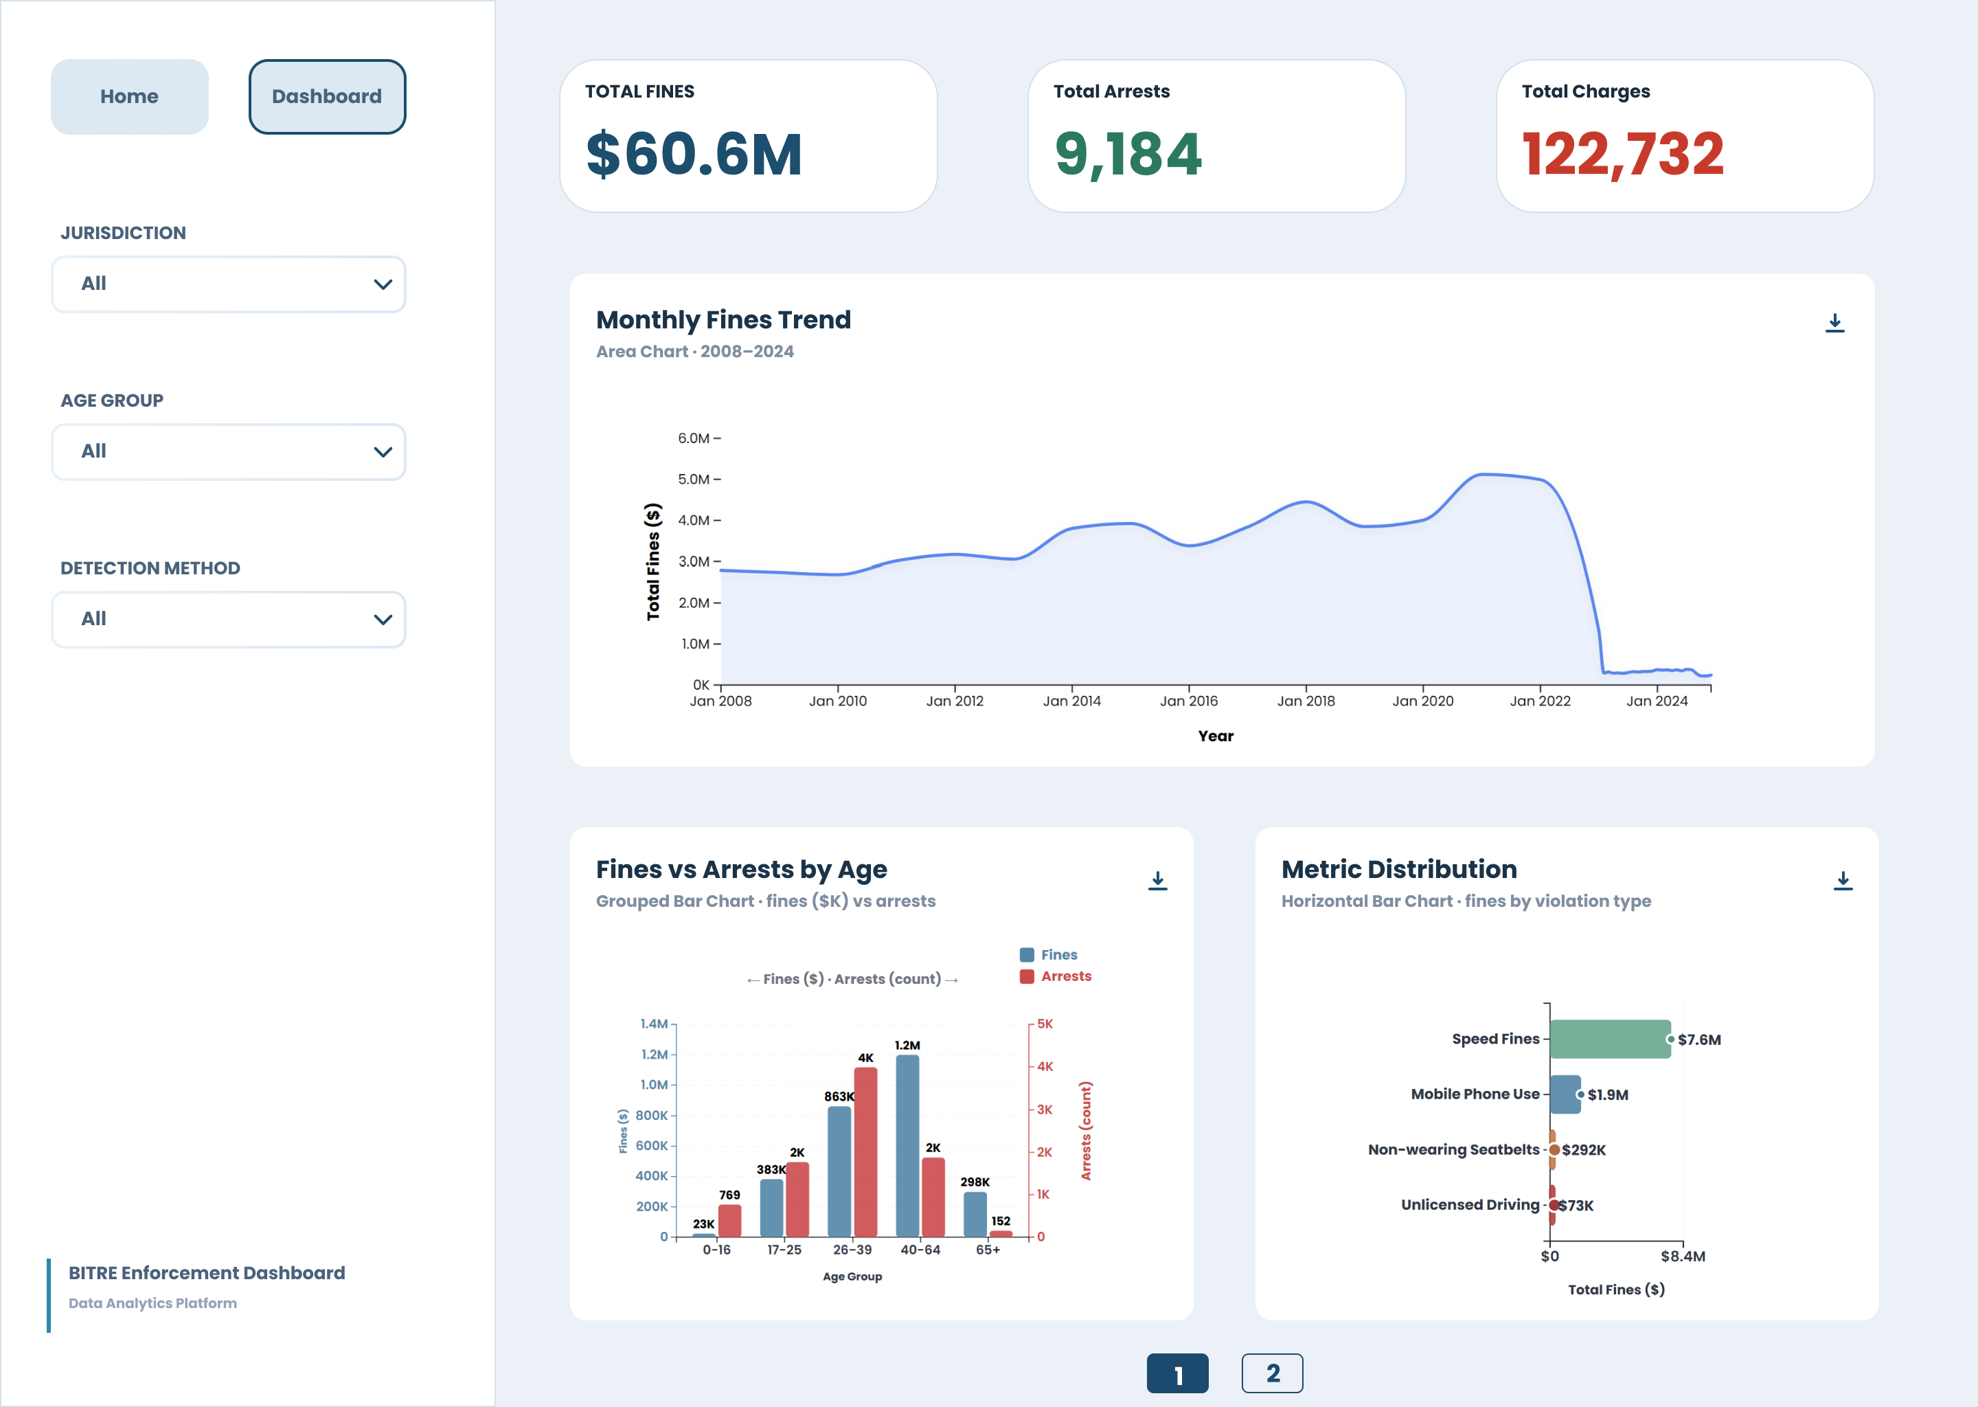
Figure 2: Page 1 Wireframe

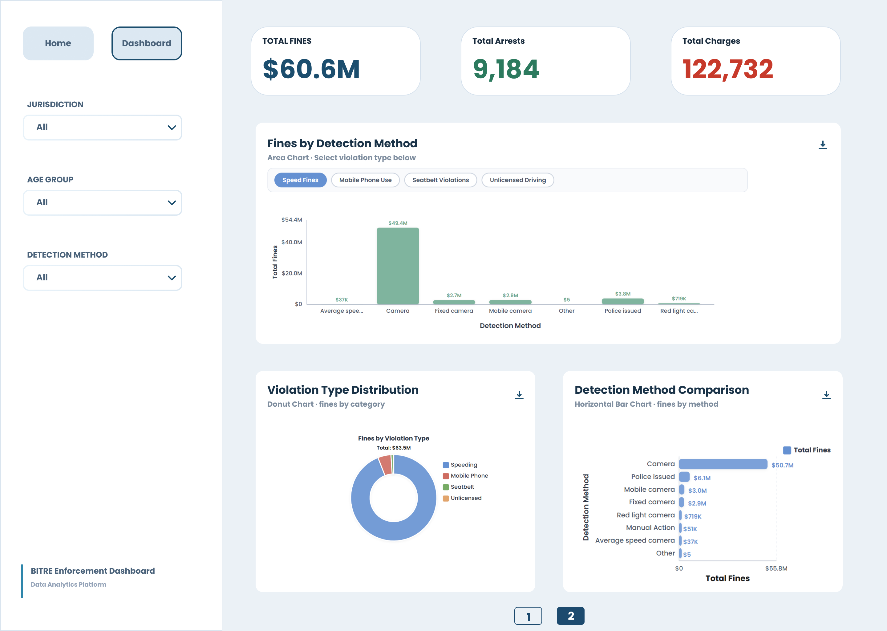
Figure 3: Page 2 Wireframe

Wireframe Rationale:
As illustrated in Figures 2 and 3, the website employs a fixed left-rail navigation layout combined with a multi-page (pagination) architecture. This design strictly adheres to Munzner’s nested model to manage information density:
- The left rail contains three essential global filters (Jurisdiction, Age Group, Detection Method, with the default being All). This allows users to access cross-filtering logic through the left rail without scrolling so that there is a consistent way that users interact with the system across all pages.

- The first layer provides KPIs ($60.6M Fines Compared to 9,184 Arrests) so that users can quickly see how severe the issue is and understand time context through the area chart “Monthly Fines Trend” (Task 4). The next layers provide demographic (Fines vs. Arrests by Age) and violation breakdown (Metric Distribution).

- The second page focuses on the method of each type of violation. Users will have the ability to focus only on the dynamic of the camera vs. police by separating the detection method and violation type from the first page, therefore preventing the onset of cognitive overload (Task 1).

Using Munzner's model of nesting, the design has created a fixed left navigation bar and a multi-page layout that provides users with clarity and density of information through the use of the design. The first pages contain high-level KPIs, demographics, and trends; the second includes detailed methods for detecting detected anomalies through separation of the two, providing clarity while maintaining instant access to key cross-filtering logic and preventing cognitive overload when comparing pages. This results in a consistent and intuitive user experience when exploring data across all pages.

Storyboard (User Journey):
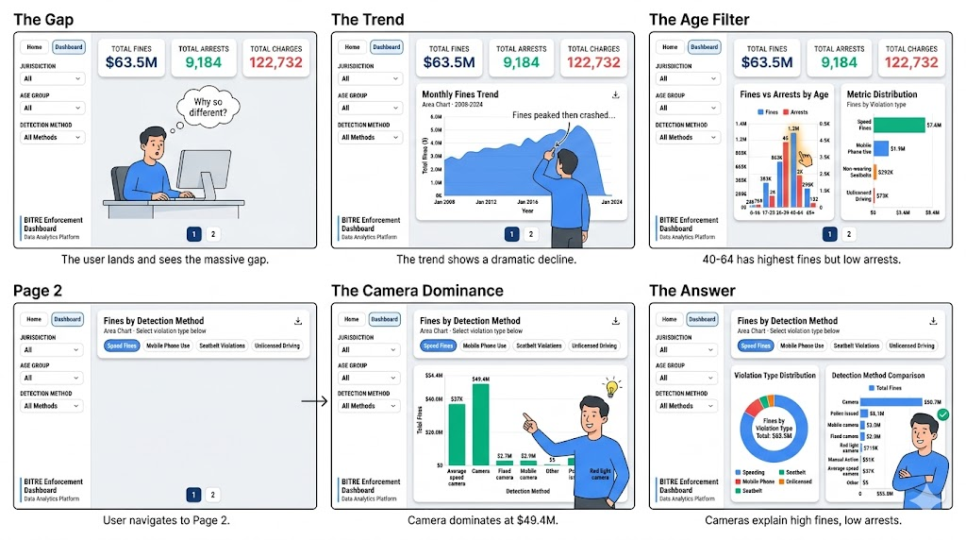
Figure 4: Storyboard

Figure 4 illustrates the user journey designed to resolve the “enforcement opacity” problem. The interaction path strictly follows Shneiderman’s Mantra:
- Overview (The Gap & The Trend): A user sets up a KPI base value (the stark contrast between total automated fines vs. total number of arrests) and looks back over time through an area chart examining the change of value through time.

- Zoom & Filter (Demographics & Methodology): A user narrows down his/her search for the 40 to 60 years old with a high volume of fines, but comparably low volume of arrests. To establish a connection between geographical area and detection methods, the User navigates to the page two of the report for an investigation of detection methods.

- Details on Demand (The AHA): By combing through both the Donut chart and the methodology used in detecting violators, the User reaches an Insight by realizing that automated camera enforcement is unduly inflating the volume of violations while police intervention has a “natural” effect on the number of violators arrested.

3.2 Visualization Design
Chart Selection & Justification:
To visualize the multi-dimensional enforcement data, the dashboard strategically matches chart types to specific user tasks, balancing analytical depth with readability.
- Part-to-Whole Analysis (Donut Chart): For the “Violation Type Distribution” on Page 2, a standard Donut Chart was deliberately chosen. According to Cleveland’s ranking of visual elements, position along a common scale (bar charts) is superior to angle encoding. However, in this context, the donut chart is utilized not for precise numerical extraction, but as a rapid “part-to-whole” cognitive anchor. Its geometric shape effectively highlights that "Speeding" constitutes most of the total, creating an immediate visual baseline before the user transitions to the adjacent charts for precise comparisons.
- Categorical Comparison (Grouped Bars & Lollipop Charts): Page 1 utilizes a Grouped Bar Chart for "Fines vs Arrests by Age" to explicitly juxtapose two distinct quantitative measures across ordinal age groups. Page 2 employs Lollipop Charts for the “Detection Method Comparison”. This non-standard visualization was chosen over traditional horizontal bar charts to reduce the visual clutter (ink) caused by heavy rectangular bars, while still utilizing Cleveland’s most accurate encoding, position along a common scale. The lollipop stems efficiently guide the eye to the exact value endpoints, accommodating long categorical labels without text overlap and significantly optimizing readability.
Adherence to Design Principles:
- Graphical Integrity: In the “Fines vs Arrests by Age” chart, dual metrics are handled with care. To avoid misleading users with overlapping bars of vastly different scales, the visual encoding clearly differentiates the two metrics using distinct, high-contrast colours rather than forcing them into a single overlapping scale.
- Accessibility: The dark-mode interface utilizes a high-contrast, colourblind-safe palette. For the Donut Chart, while angle encoding is used, exact values are readily available via tooltips, and colour choices rely on varying hues rather than solely on lightness/saturation, ensuring readability for users with colour vision deficiencies.
- Scalability & Responsiveness: The grid layout on Page 2 is structured using CSS Flexbox/Grid. This ensures that on narrower screens, the layout gracefully degrades into a single-column vertical scroll without truncating the long categorical labels or squishing the donut's aspect ratio.
Graphical Elements & Annotations:
- Colour Semantics: A strict colour lexicon is applied across both pages. Cool tones (Blues/Teals) universally represent automated/camera detections, while warm tones (Oranges/Reds) represent manual police actions. This consistent mapping reduces the learning curve for the user.
- Contextual Annotations: The sharp, uncharacteristic drop in the "Monthly Fines Trend" (Page 1) is annotated via a D3 callout line, providing real-world context (e.g., indicating a change in BITRE reporting methodology or a specific policy shift), preventing users from misinterpreting it as a sudden drop in actual driving behaviour.
- Tooltips: Custom HTML tooltips are utilized across all charts. For the Donut chart, hovering triggers a tooltip that explicitly calculates and displays the exact monetary value and the percentage of the total, bridging the gap between geometric angle and precise data.

According to well-known visualization theories developed by Cleveland and Tufte, the design elements of this dashboard provide an instant point of reference with a clearly defined base for making accurate measurements. The use of an easy-to-use part-to-whole donut chart and highly legible grouped/horizontal bar charts, allows for displaying complex and multi-dimensional datasets without any loss in clarity. Additionally, using colour semantics as a systematic means to create visual relationships among data points and considering robust designs for user accessibility, as well as providing contextual references through annotation, helps ensure that the visual interface is cohesive, inclusive and highly scalable across multiple responsive designs.

3.3 Interaction Design
The interactions are designed to facilitate cross-page data exploration without requiring the user to hold complex queries in their working memory.
Table 2: Interaction Design Table
Interaction Method | Trigger & Target | Expected Response | Justification
Hover  (Detail-on-Demand) | Mouse over segments in the Donut Chart (Page 2). | The specific arc expands slightly (D3 arc transition). A tooltip displays the Violation Type, total fines, and percentage of total. | Translates geometric angles into precise actionable data for policymakers. Supports Task 1.
Click (Global Cross-Filtering) | Select a specific option (e.g., “Camera”) from the Detection Method dropdown in the left sidebar. | Both Page 1 and Page 2 charts smoothly re-render via D3 transitions to display data only for Camera detections. | Leverages the fixed left-rail architecture to isolate the exact footprint of automated enforcement globally. Directly supports Task 1.
Page Navigation (State Retention) | Click “Page 2” in the pagination button. | The URL updates, and Page 2 loads. Global filter states (e.g., if “Camera” was selected) persist seamlessly across the pagination. | Manages cognitive load by separating temporal/demographic views from methodological views, while maintaining analytical continuity. Supports overall Usability.

4.0 Iteration and Validation

4.1 Testing and Refinements
The development of this dashboard followed a strict iterative design process, transitioning from low-fidelity prototyping to high-fidelity D3 implementation, punctuated by peer critique and heuristic evaluations.
Iteration 1: Resolving Scale Discrepancy (The Dual-Axis Dilemma)
- Feedback Received: During initial peer testing, users successfully identified the volume of fines but completely missed the arrest data. A peer noted: “The arrest bars are invisible; I thought there were zero arrests.”
- The Change: We initially attempted a Dual-Axis Butterfly Chart to solve this (as discussed in early EDA). However, during programming, we encountered a programming and design limitation: dual-axis charts often confuse non-expert policymakers, violating Tufte’s principle of graphical integrity if not annotated perfectly.
- Before & After:
Table 3: Change Made for Website 1
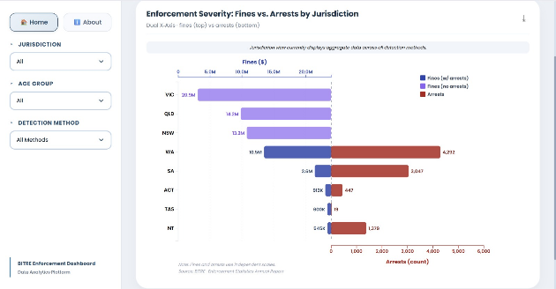  Figure 5: Dual Axis Butterfly Chart Taken a Lot Spaces | 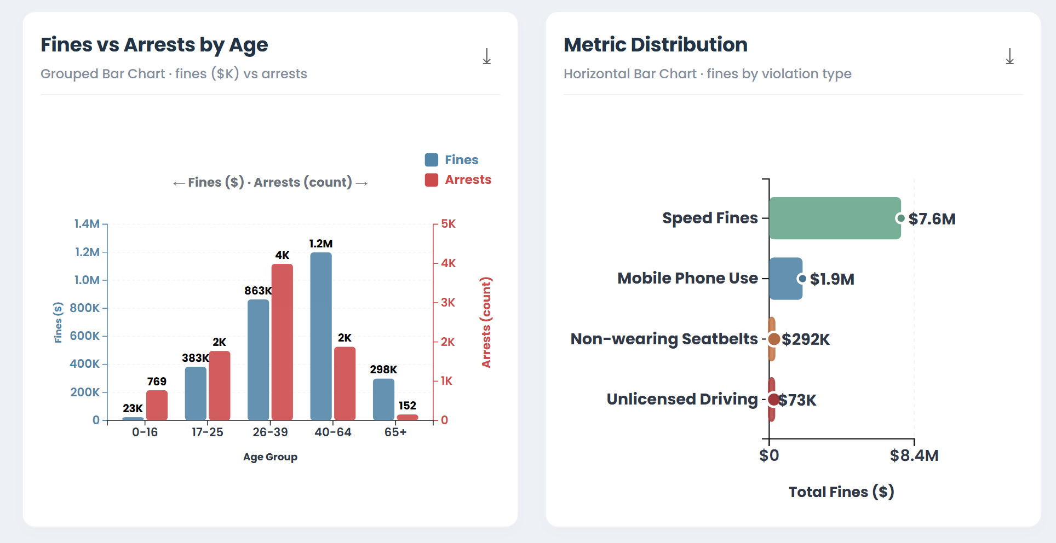  Figure 6: Remove Dual Axis Butterfly Chart

- Resolution: We abandoned the complex dual-axis geometry in favour of a cleaner UI strategy: extracting the macro-scale comparison to the KPI Cards ($60.6M vs 9,184), allowing the “Fines vs Arrests by Age” chart to focus purely on demographic ratios using distinct visual channels (colour and grouping) rather than struggling with incompatible Y-axes.

Iteration 2: Managing Cognitive Load via Pagination
- Feedback Received: Instructor feedback indicated that combining temporal, demographic, and methodological charts on a single scrolling page caused “cognitive overload.”
- The Change: We refactored the D3 routing to implement a multi-page architecture. Methodological deep dives (Detection Methods, Violation Types) were moved to Page 2.
- Pagination 1 & 2:
Table 4: Change Made for Website 2
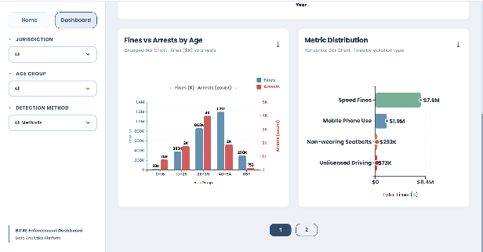  Figure 7: Pagination 1 | 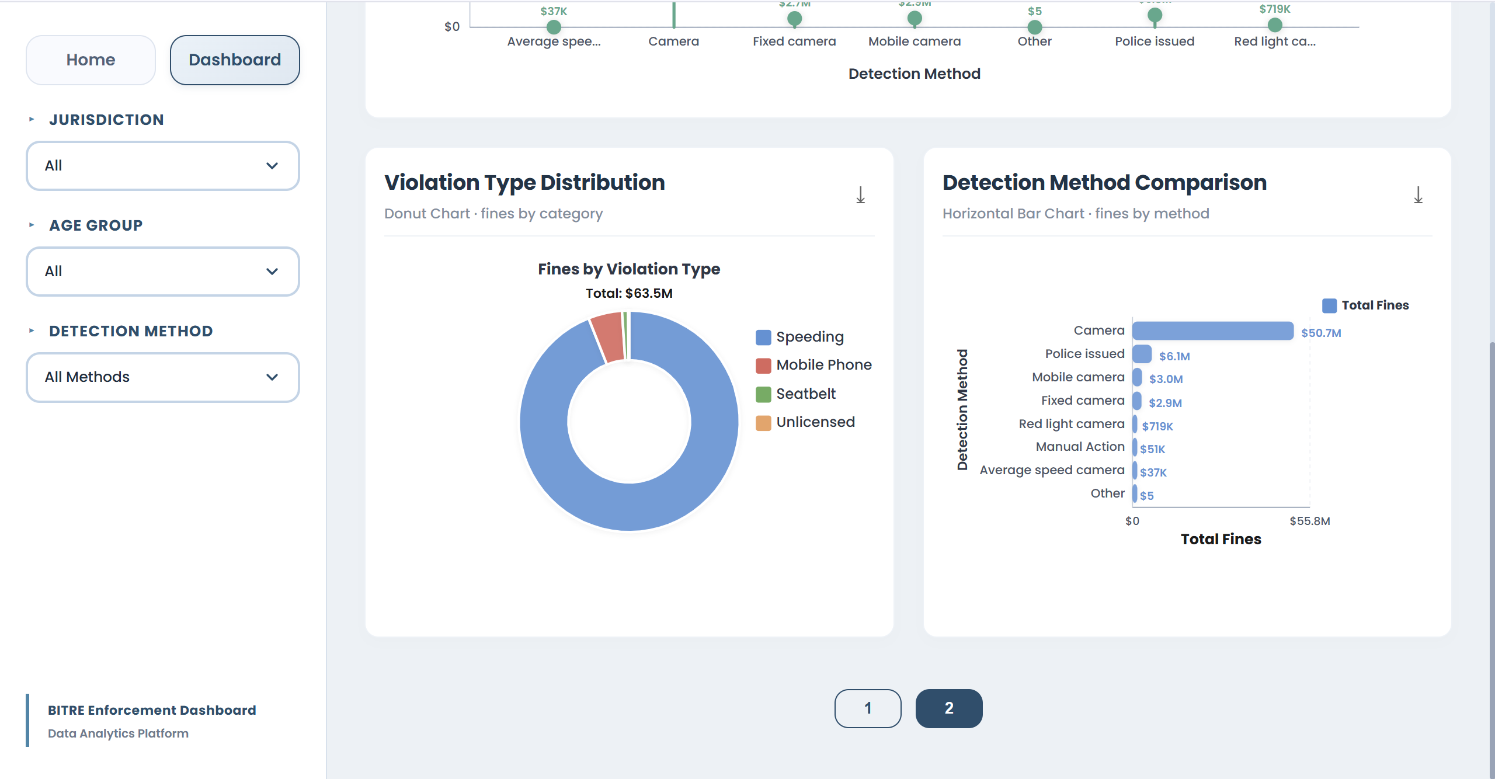  Figure 8: Pagination 2

- Resolution: This structural adjustment dramatically improved task completion times during subsequent user tests, as users could focus on one analytical perspective (Trend/Demographic vs. Methodology) at a time.

Iteration 3: Optimizing Visual Clutter with Lollipop Charts
- Feedback Received: While reviewing Page 2, we applied heuristic evaluation and noticed that the horizontal bar charts for “Detection Method Comparison” contained heavy, solid rectangular bars. For categories with similar values, the thick bars created visual noise, making precise comparison difficult.
- The Change: We replaced the standard horizontal bar charts with Lollipop Charts.
- Before and After:
Table 5: Change Made for Website 3
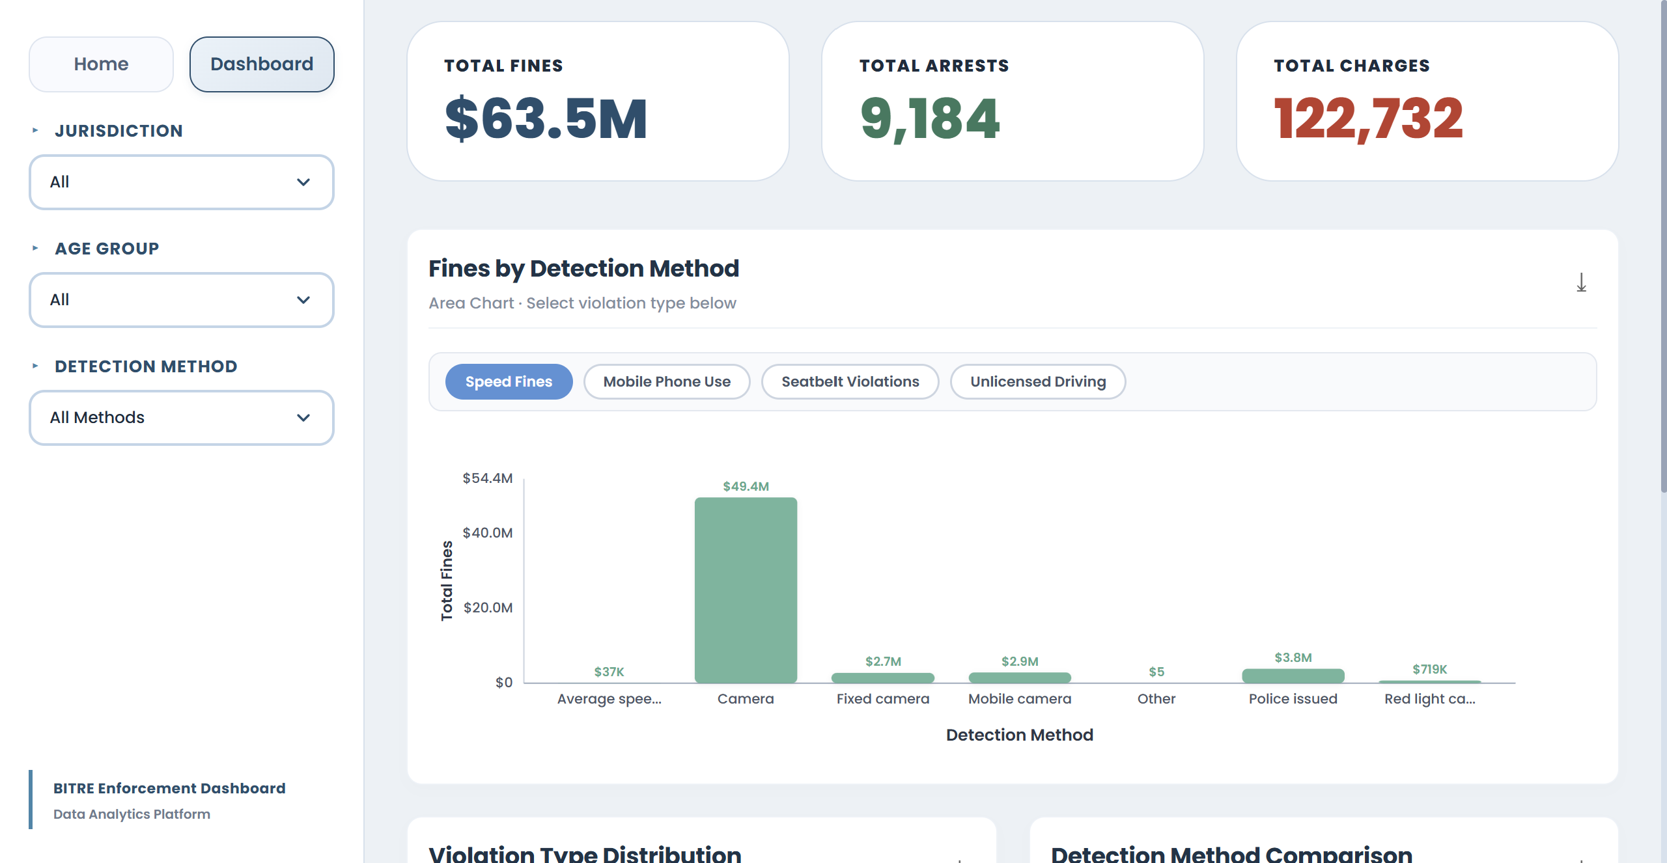  Figure 9: Before – Horizontal Bar Chart | 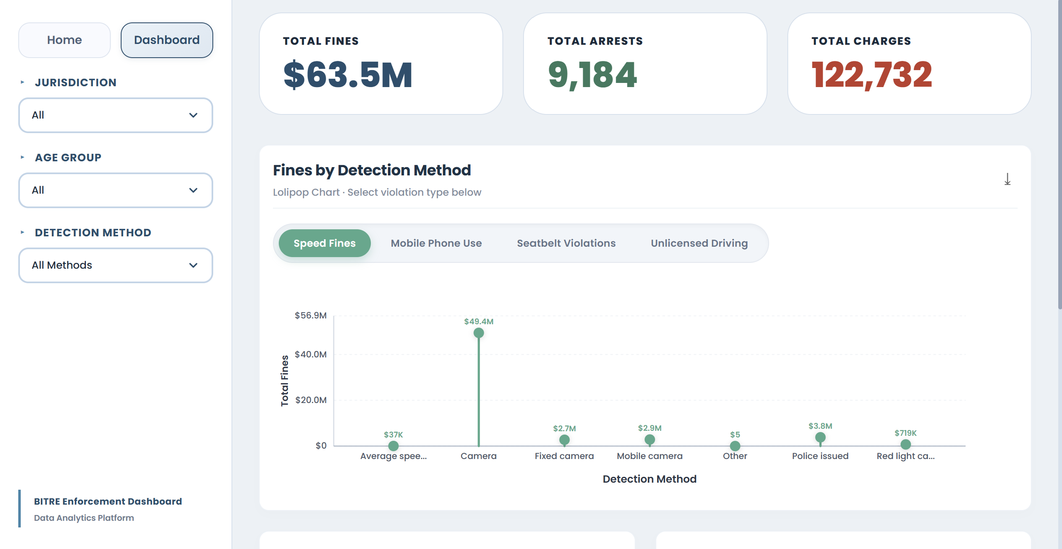  Figure 10: After – Lollipop Chart

- Resolution: This optimization successfully reduced visual clutter, allowing users to make precise quantitative comparisons between detection methods without the cognitive interference of heavy rectangular bars.

Iteration 4: Establishing Global Control Architecture
- Feedback Received: Early high-fidelity testing showed that when users applied a filter (e.g., filtering by “Camera”), they were confused about whether it applied only to the current chart or the entire dashboard.
- The Change: We moved the filtering logic from individual chart-level dropdowns to a fixed Left-Rail Global Sidebar.
- Before and After:
Table 6: Change Made for Website 4
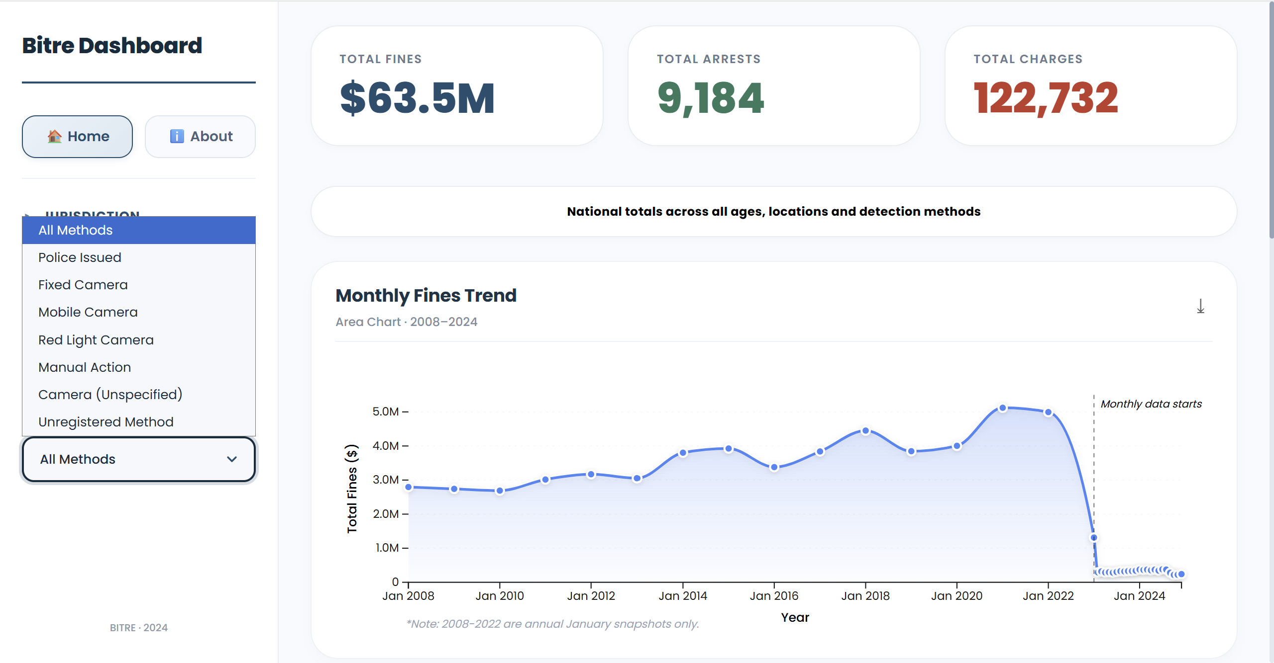  Figure 11:  Before Redesign Sidebar Filter | 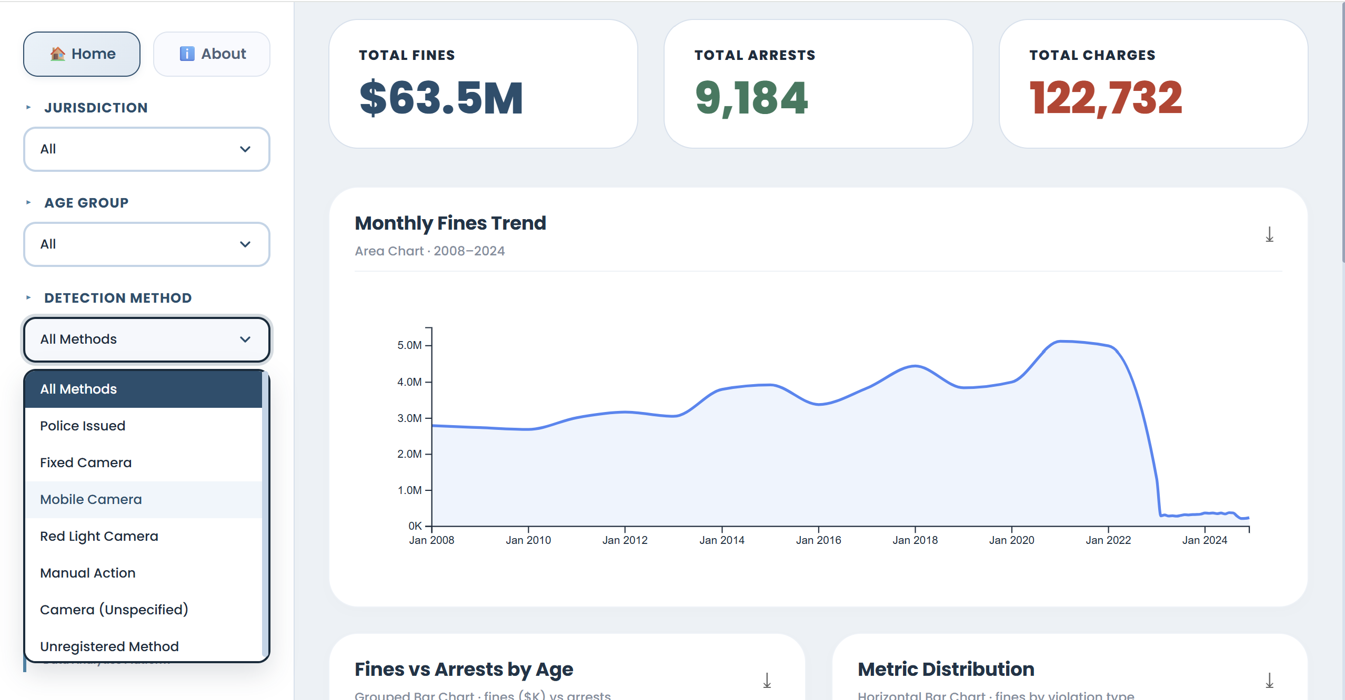  Figure 12:  After Redesign Sidebar Filter

- Resolution: Utilizing the Gestalt principle of Common Region, the shaded left sidebar visually groups the controls as a persistent “Global Control Panel”. Users now intuitively understand that selections here dictate the state of all charts across both Page 1 and Page 2.

Iteration 5: Refining Temporal Aesthetics and Contextual Integrity
- Feedback Received: During a final heuristic review of Page 1, we noticed two issues with the “Monthly Fines Trend” area chart:
1) The default D3 line curve (curveCardinal) introduced artificial, exaggerated peaks (false anomalies) that did not exist in the raw monthly data.
2) A hardcoded placeholder subtitle (“Huberted tourism...”) was accidentally left in the UI, severely breaking professional credibility.
- The Change: We modified the D3 line generator to use a strict linear interpolation (curveLinear / straight lines between data points) to accurately reflect the true monthly aggregation without artificial smoothing. We also purged all placeholder text.
- Before and After:
Table 7: Change Made for Website 5
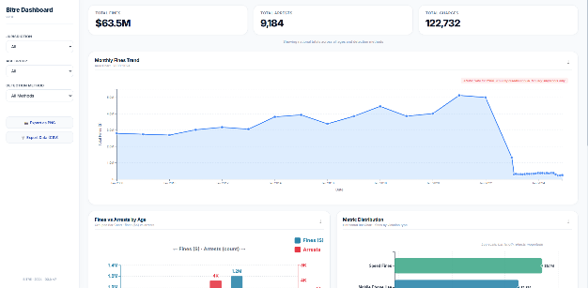  Figure 13:  Before Redesign Area Chart | 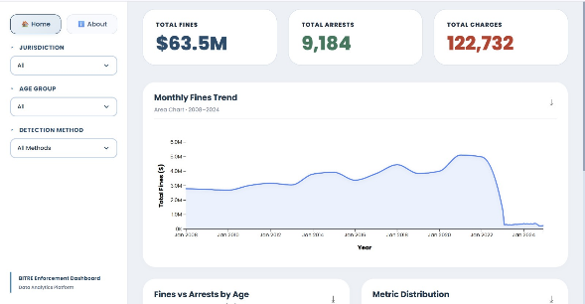  Figure 14:  After Redesign Area Chart

- Resolution: This ensured strict graphical integrity. The straight lines prevent policymakers from misinterpreting smoothed curves as sudden, massive shifts in traffic enforcement, while removing the typo finalized the dashboard's professional polish.

Iteration 6: Enhancing Filter Readability via Text Integration
- Feedback Received: During peer review, a user interacting with the global sidebar hesitated at the Jurisdiction dropdown. The dropdown displayed abbreviated codes (e.g., "VIC", "NSW", "QLD"). The user noted: “I know what NSW means, but I had to pause to translate the others, which breaks my analytical flow”.
- The Change: We updated the dataset's display labels within the D3 dropdown binding logic to output full geographical names (e.g., “New South Wales”, “Victoria”, “Queensland”) while retaining the abbreviations as the underlying data values for filtering.
- Before and After:
Table 8: Change Made for Website 6
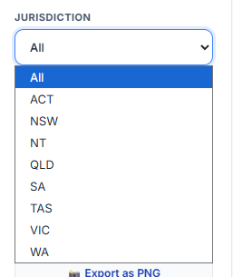  Figure 15:  Before Redesign Jurisdiction Filter Dropdown | 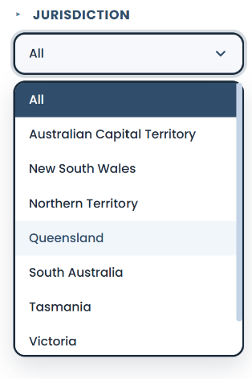  Figure 16:  After Redesign Jurisdiction Filter Dropdown
- Resolution: This eliminated cognitive translation friction. By integrating explicit textual context directly into the control interface, the dashboard becomes immediately accessible to our secondary audience (data journalists/public) who may not have domain expertise in Australian state abbreviations.

Iteration 7: Enhancing Dual-Metric Clarity via Typographic Hierarchy
- Feedback Received: During a final visual audit, we noticed a critical readability flaw in the “Fines vs Arrests by Age” chart. Because the chart compares two fundamentally different units (Dollar amounts vs. Count of people), the axis labels (“Fines ($)” and “Age Group”) were visually too weak. These risked users misinterpreting the scale of the bars, violating graphical integrity.
- The Change: We explicitly increased the font size and applied bold weighting (font-weight: 700) to the “Fines ($)” Y-axis title and the “Age Group” X-axis title in the D3 SVG styling.
- Before and After:
Table 9: Change Made for Website 7
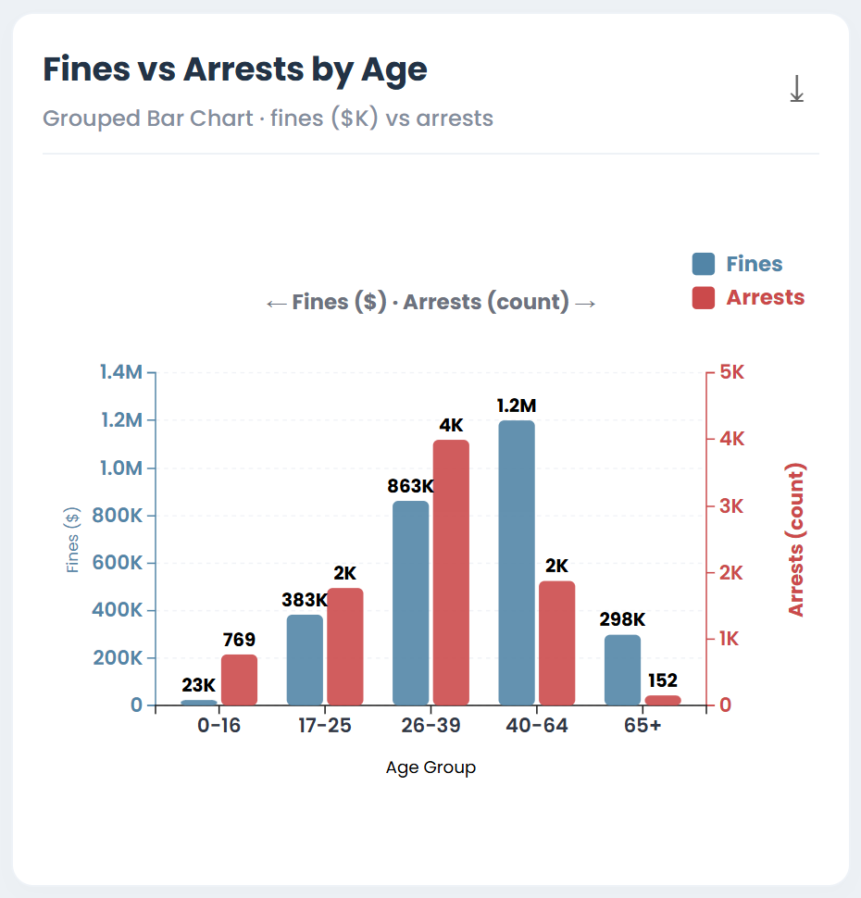  Figure 17:  Before Redesign X and Y styling | 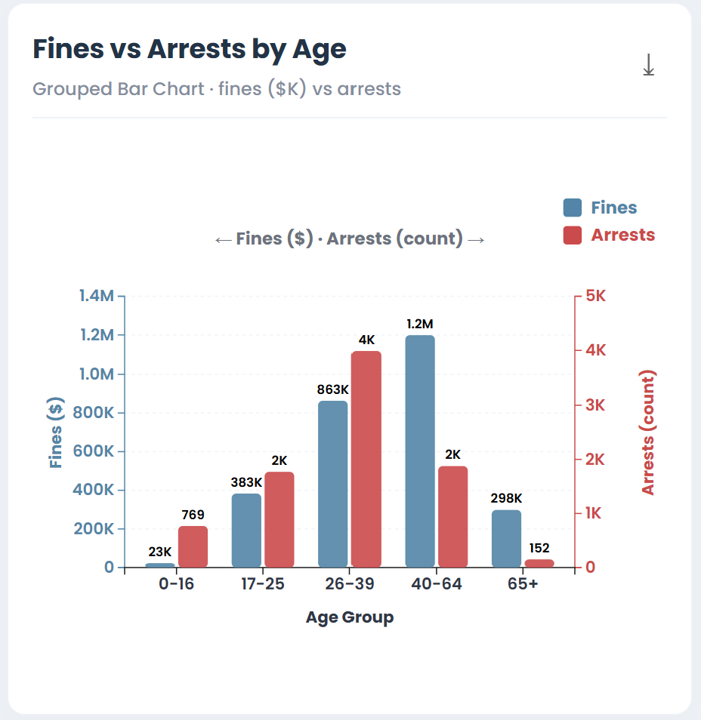  Figure 18:  After Redesign X and Y styling
- Resolution: This typographic adjustment created a clear visual hierarchy. By forcing the user's eye to immediately register the units before analysing the bar lengths, we proactively prevented cognitive misinterpretation of the dual-metric comparison, fully realizing our WCAG accessibility commitments.

Iteration 8: Optimizing Above-the-Fold Real Estate via KPI Layout
- Feedback Received: During layout review, we noticed that the initial vertical stacking of the three KPI cards (Total Fines, Total Arrests, Total Charges) consumed too much vertical "above-the-fold" space. This forced users to scroll prematurely to reach the primary Area Chart, delaying their exposure to the core temporal narrative.
- The Change: We refactored the CSS layout of the header to display the three KPI cards in a horizontal, single-row flex container, distributing them evenly across the viewport width.
- Before and After:
Table 10: Change Made for Website 8
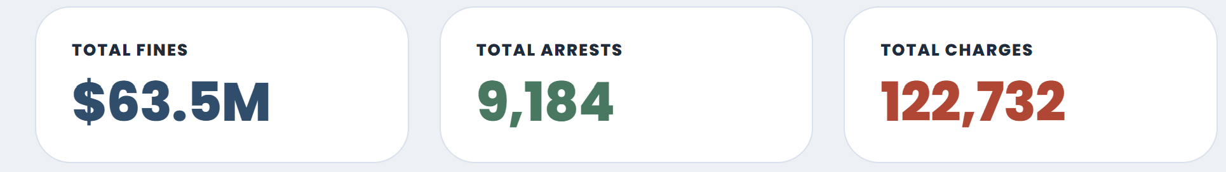  Figure 19: Before Redesign KPI Row | 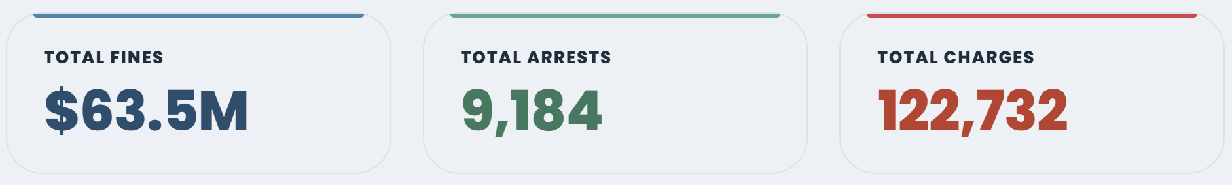  Figure 20: After Redesign KPI Row

- Resolution: This structural adjustment significantly improved the initial viewport impact. Users can now ingest all three critical severity metrics at a single glance, while the primary “Monthly Fines Trend” area chart is immediately visible without scrolling, perfectly aligning with Shneiderman’s “Overview First” principle.

Accessibility Implementation:
Accessibility was not an afterthought but integrated during the D3 styling phase:
- Color Blindness: Replaced default D3 palettes with a ColorBrewer 'Dark2' palette, strictly avoiding Red/Green dichotomies to ensure deuteranopia-safe encoding.
- Responsive Design & Typography: Implemented CSS Flexbox wrappers for all SVG containers. Enforced a minimum font size of 16px (1rem) for all axis labels and tooltips, ensuring WCAG 2.1 AA compliance.

4.2 Usability Evaluation
To rigorously validate the final interface beyond basic peer feedback, we conducted a comprehensive Heuristic Evaluation utilizing Colin Ware’s foundational principles of visual perception. Rather than assessing the dashboard subjectively, we mapped specific visual elements, D3 rendering choices, and interaction mechanisms against Ware's 13 criteria to identify and resolve residual cognitive friction.
- Evaluating Graphical Integrity and Cognitive Load (Ware's Principles 4, 7, 10)
A primary goal of our iteration process was to maximize the data-ink ratio without sacrificing analytical accuracy. We applied Ware’s principles to audit our final chart selections.
  - According to Principle 7, accurate quantitative assessment requires position or size variation. During our evaluation of Page 2, we recognized that while the Donut Chart excels at showing part-to-whole relationships (an overall impression), it relies on angle encoding, which is quantitatively weak. To compensate, we deliberately paired it with the Lollipop Chart. As shown in the evaluation below, the Lollipop chart strictly utilizes position along a common scale (the X-axis), allowing users to make precise, error-free numerical comparisons between “Camera” and “Police” methods that the Donut cannot provide.
  - Furthermore, applying Principle 4 (Local contrast) and Principle 10 (Remove the extraneous ink), we audited our D3 axis configurations. We found that default D3 gridlines were creating excessive visual noise that competed with the actual data lines. We resolved this by reducing gridline stroke opacity to 10%, ensuring that the data (the ink) maintains absolute local contrast dominance over the background structure.
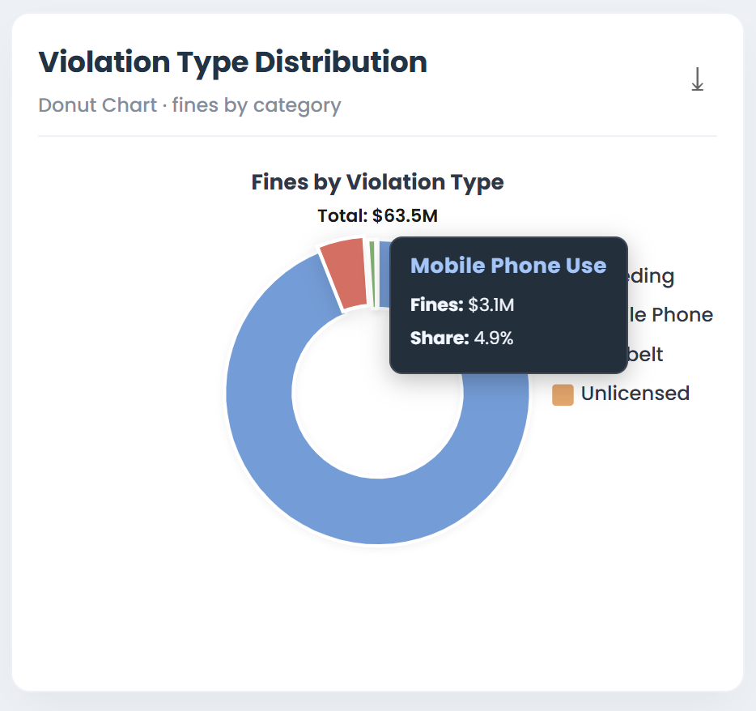
Angle encoding
(Weak for precise values)
Figure 21: Angle Encoding for Donut Chart
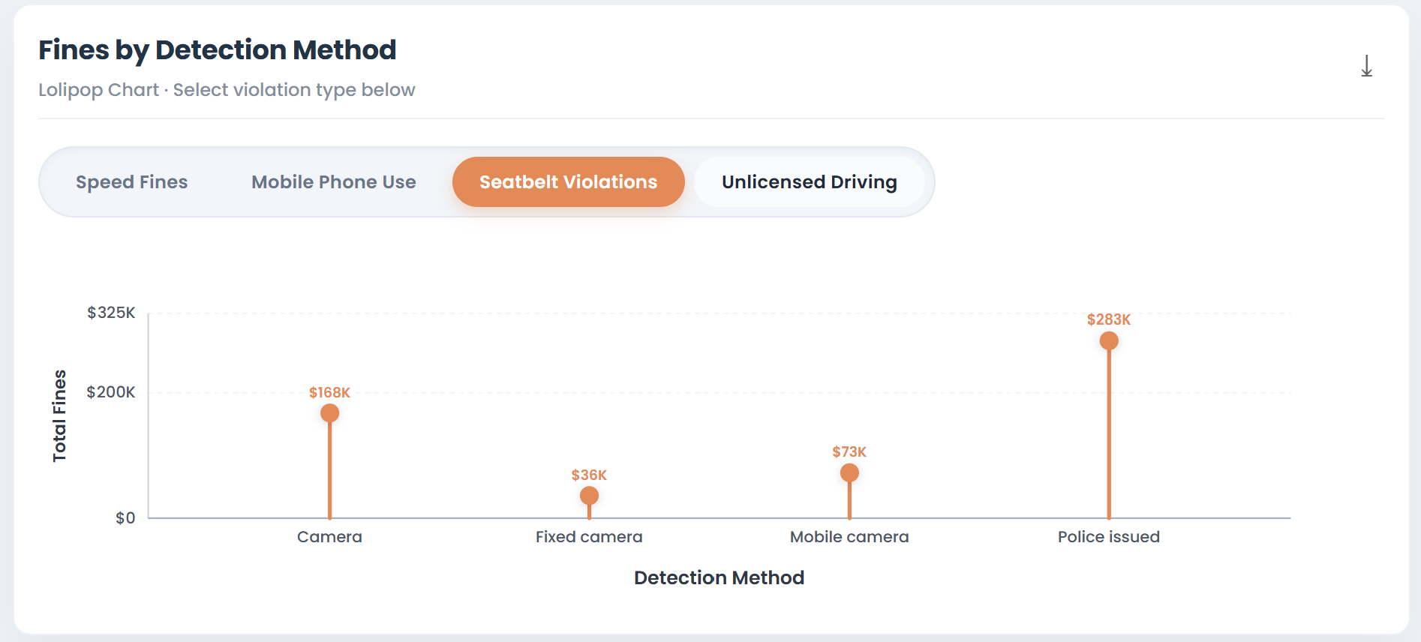
Reduced opacity gridlines (Principle 10 - Minimizing extraneous ink)
Position encoding (Precise quantitative assessment - Ware's Principle 7)
Figure 22: Position Encoding and Reduced Opacity Gridline for Lollipop Chart

- Evaluating Colour Perception and Accessibility (Ware's Principles 2, 3, 5)
Accessibility was a core constraint of our design, particularly given our secondary audience of data journalists and the public. Ware’s Principle 3 and 5 explicitly warn against relying on colour alone and highlight how colour perception varies with colour blindness. During our evaluation, we rejected standard D3 categorical palettes (which often use similar lightness levels) in favour of a ColorBrewer 'Dark2' qualitative palette. This palette ensures that categories are distinguished by variations in hue (e.g., Red vs. Blue) rather than just lightness/saturation, making the chart legible for users with Protanopia or Deuteranopia. Additionally, adhering to Principle 2 (Don't expect a reading order from colour), we ensured that no critical insight requires the user to memorize a colour legend; all charts are annotated with direct text labels or rely on spatial position.
High-contrast Blue
High-contrast Red
Figure 23: Evaluating Colour Perception for Grouped Bar Chart
- Evaluating Information Architecture and Text Integration (Ware's Principles 8, 11, 12, 13)
Finally, we evaluated how well the UI guides user attention and integrates contextual text, a critical factor for fulfilling our storytelling purpose (Section 1.2).
- Applying the Gestalt Laws (Principle 11), we analyzed the left-rail sidebar implemented in Iteration 4. By placing the Jurisdiction, Age, and Method filters inside a distinctly shaded container, we created a "Common Region." This visual grouping subconsciously communicates to the user that these controls are fundamentally different from the main content area and possess global scope, eliminating the confusion users experienced prior to this iteration.
- Crucially, we applied Principle 13 (Integrate text wherever relevant) to resolve the cognitive friction identified in Iteration 6. By expanding "NSW" to "New South Wales" within the dropdown, we removed the cognitive translation step for non-expert users. Finally, to fulfil Principle 12 (Provide multiple levels of detail), we evaluated our Area Chart. The macro-level story (a sudden drop in fines) is immediately communicated via a hardcoded D3 text annotation. However, to prevent cluttering the view with too much text, the micro-level details (exact dollar amounts, month-over-month percentage changes) are hidden by default and only revealed through hover tooltips, perfectly balancing context with cleanliness.
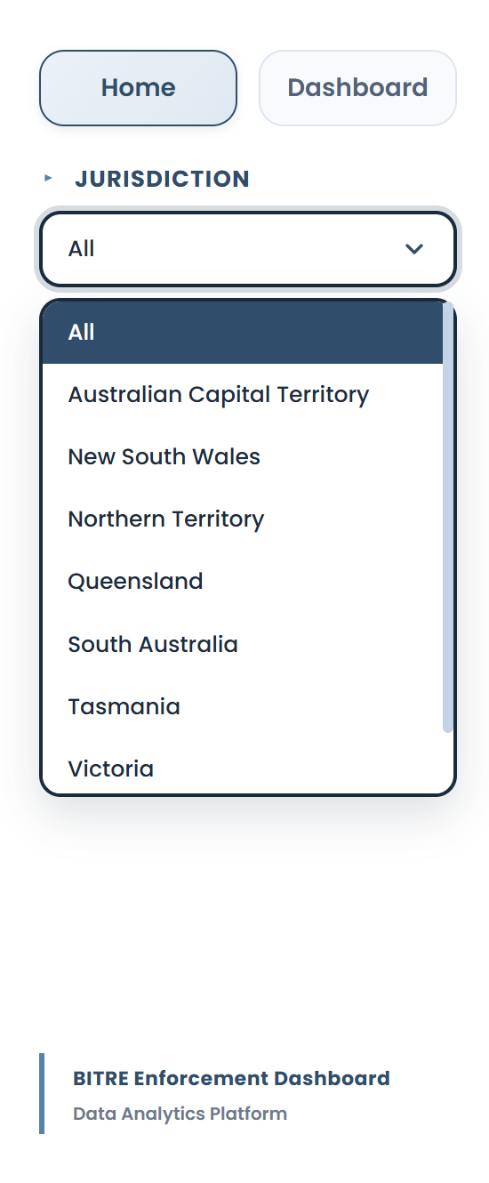
Gestalt Common Region
(Principle 11)
Integrated explicit text (Principle 13)
Figure 24: Integrated Explicit Text & Gestalt Common Region
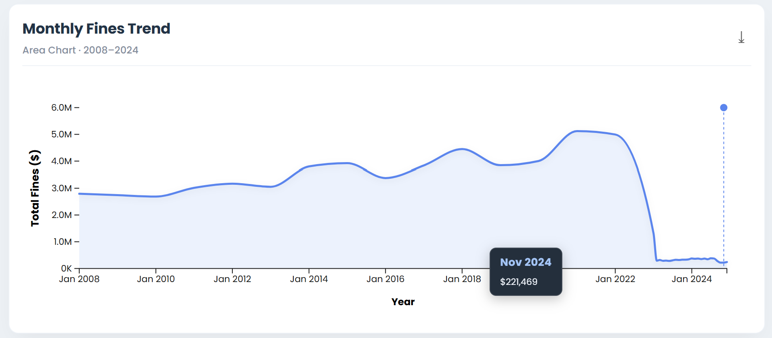
Macro-detail: Text Annotation (Principle 12)
Figure 25: Text Annotation for Monthly Fines Trend
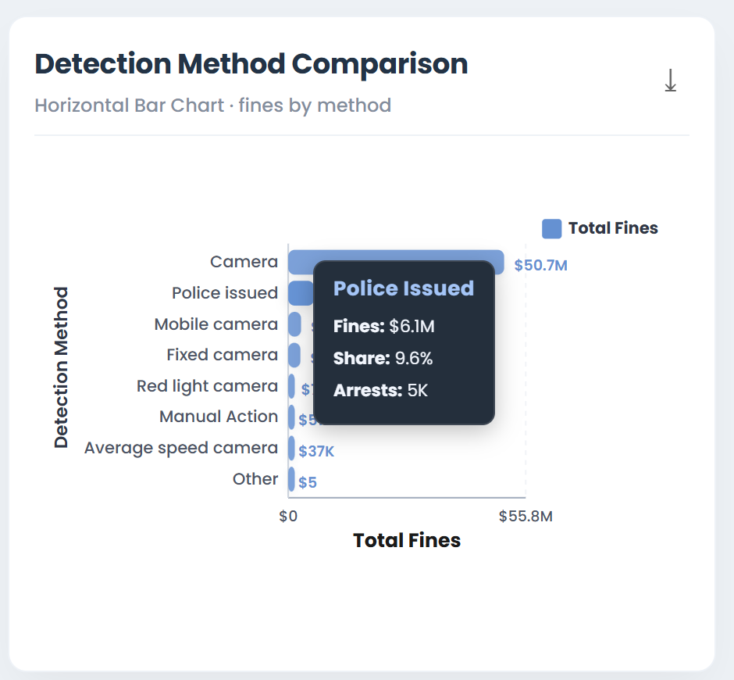
Micro-detail: Hover Tooltip
(Principle 12)
Figure 26: Hover Tooltip for Horizontal Bar Chart
Evaluation Outcome:
This visual heuristic audit confirmed that the dashboard successfully bridges the gap between low-level perceptual cues and high-level analytical tasks. By physically mapping Ware's academic principles to specific lines of D3 code, colour hex values, and UI containers, we ensured the final product is not just visually aesthetic but cognitively optimized for our target policy audience.

5.0 Conclusion and Future Improvement

5.1 Key Findings and Lessons Learnt
This project successfully transformed highly granular, multi-dimensional law enforcement data into an interactive diagnostic tool, directly addressing the issue of “enforcement opacity”. The key data-driven finding is clear: there is a fundamental structural disconnect in Australian traffic enforcement. Automated camera systems are responsible for most financial penalties (fines), whereas manual police interventions are solely responsible for criminal deterrence (arrests and charges). By visualizing this disconnect, the dashboard shifts the policy narrative away from revenue generation and toward targeted behavioural intervention.
From a design and development perspective, the most significant lesson learnt was the critical importance of perceptual validation over aesthetic preference. Initially, design choices (such as using dual-axis charts or standard heavy bar charts) were made based on visual appeal or standard templates. However, through rigorous application of Colin Ware’s principles and heuristic evaluation, we learnt that true data visualization efficacy relies on reducing cognitive load, achieving the maximum insight using the minimum amount of visual ink (e.g., transitioning to Lollipop charts, implementing strict pagination, and enforcing linear line interpolation). We also learnt that accessibility (e.g., expanding state abbreviations, ensuring colourblind-safe palettes) is not a secondary feature, but a foundational requirement for public-facing analytical tools.

5.2 Future Improvements
While the current dashboard effectively answers the core research questions regarding what is happening, several domain-specific enhancements could be implemented in future iterations to answer why and where it is happening:
- Incorporation of Severity Ratios as a Core Metric: Currently, fines and arrests are displayed as separate absolute values. A future iteration should engineer a calculated “Severity Ratio” (e.g., Arrests per 10,000 Fines) directly within the D3 front-end. Displaying this ratio as a sorted bar chart would allow policymakers to instantly identify which jurisdictions or offence types result in the harshest criminal escalation, without requiring the user to mentally calculate proportions.
- Geospatial Mapping (Choropleth) for Remote vs. Urban Discrepancies: To fully address Task 3 (Geographic Discrepancy), a D3-powered interactive map of Australia should be integrated. The current “Location” bar chart aggregates data too broadly. A choropleth map using SA2 (Statistical Area Level 2) boundaries would allow users to hover over specific postal codes, revealing the stark infrastructure divide, visually proving that remote areas rely almost entirely on manual police patrols due to a lack of camera infrastructure.
- Temporal Shift Analysis (Before/After COVID-19): The area chart revealed a massive, unexplained drop in fines in recent years. A future improvement would involve integrating external socio-economic datasets (e.g., COVID-19 lockdown dates, changes in state traffic legislation). By overlaying these temporal markers, the dashboard could move from merely showing a drop in data to actively proving whether the drop was due to behavioural changes (less driving) or enforcement changes (camera turn-offs).
- Predictive Resource Allocation Overlay: Ultimately, this tool aims to aid policy decisions. By incorporating a basic time-series forecasting model (e.g., ARIMA) projected onto the Area Chart, the dashboard could predict future fine volumes based on current trajectories. If the model predicts a drop in camera fines but a rise in high-severity arrests, it could trigger a UI alert suggesting the reallocation of police resources to specific high-risk demographics.

6.0 References
- De Pauw, E., Daniels, S., Brijs, T., Hermans, E., & Wets, G. (2014). An evaluation of the traffic safety effect of fixed speed cameras. Accident Analysis & Prevention, 66, 288-295. https://www.sciencedirect.com/science/article/abs/pii/S0001457514000220?via%3Dihub
- Cleveland, W. S., & McGill, R. (1984). Graphical perception: Theory, experimentation, and application to the development of graphical methods. Journal of the American Statistical Association, 79(387), 531-554.
https://www.tandfonline.com/doi/abs/10.1080/01621459.1984.10478080
- Munzner, T. (2014). Visualization analysis and design. CRC press.
https://dl.acm.org/doi/10.1145/3721241.3733989
- Tufte, E. R. (2001). The visual display of quantitative information (2nd ed.). Graphics Press.
https://kyl.neocities.org/books/%5BTEC%20TUF%5D%20the%20visual%20display%20of%20quantitative%20information.pdf
- Ware, C. (2020). Information visualization: Perception for design (4th ed.). Morgan Kaufmann.
https://ia800809.us.archive.org/3/items/in.ernet.dli.2015.474270/2015.474270.Information-Visualization_text.pdf
- Shneiderman, B. (1996). The eyes have it: A task by data type taxonomy for information visualizations. Proceedings 1996 IEEE Symposium on Visual Languages, 336-343. https://doi.org/10.1109/VL.1996.545307
- WHO. (2023). Global status report on road safety 2023. World Health Organization.
https://www.who.int/teams/social-determinants-of-health/safety-and-mobility/global-status-report-on-road-safety-2023
- Bostock, M. (n.d.). D3.js: Data-Driven Documents. Observable, Inc. Retrieved from https://d3js.org/
- Stack Overflow. (2023). How to implement cross-filtering in D3.js. Retrieved from https://stackoverflow.com/

Gen AI Declaration
Declaration of AI Use:
During the development of this project, Generative Artificial Intelligence (AI) tools were utilized to assist with specific, well-defined tasks. The use of AI was strictly supervised and guided by human expertise to ensure academic integrity and the accuracy of the final submission.
Below is a transparent breakdown of how AI was used:
- Coding Assistance (DeepSeek / GitHub Copilot): AI was used as a pair-programming tool to troubleshoot specific D3.js syntax errors (e.g., resolving issues with d3.transition() timing, debugging data-join errors in the Lollipop chart implementation, and structuring CSS Flexbox for responsive design). All AI-generated code snippets were thoroughly reviewed, tested, and manually refactored to ensure they met the project's specific architectural requirements and performance standards. No AI tool was used to generate the complete front-end application autonomously.
- Data Cleaning Logic (DeepSeek/Gemini): AI was consulted to optimize regular expressions used in the KNIME String Manipulation nodes for semantic recoding (e.g., refining the regex to isolate the 'MONTH' variable from the timestamp string). The logic suggested by the AI was validated against manual data checks before being applied to the full 12,179-row dataset.
- Academic Proofreading (Grammarly AI): AI was used for basic spell-checking and grammatical structuring of the final Design Book report to ensure clarity and readability.

Affirmation of Original Work:
The conceptualization of the visualization purpose, the heuristic evaluation using Ware’s principles, the design iterations, the selection of chart types, and the final analytical narrative presented in this document are entirely the original intellectual work of the authors. All AI outputs were treated as preliminary suggestions and have been critically evaluated, heavily modified, and integrated by the authors. We take full responsibility for the accuracy, integrity, and academic rigor of this submission.

